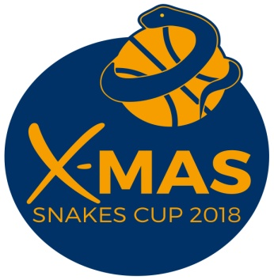
X-MAS SNAKES CUP 2018
INTERNATIONAL YOUTH BASKETBALL TOURNAMENT
Category U15
OSTRAVA, CZECH REPUBLIC, 14. – 16.12.2018

APPLICATION FORM
BASKETBALL CLUB ……………………………………………………………………………..…………..
ADRESS ………………………………………………………………………………………………….………..
CONTACT PERSON……………………………..…………………………………………………….………
TELEPHONE………… ………….…………………………………………………………………….………..
THE NAME OF COACH……………………………………………………….. …………………………….

NUMBER OF PLAYERS ………………….…..………...….
NUMBER OF COACHES…………………………….,….….
NUMBER OF ACCOMPANIMENTS…………………….
TOTAL NUMBER OF PERSONS ………………..………

14.-16.12.2018 - The price is 20.000.-Kč/ 800.-EUR per team 12 players-persons. 1 coach for free. The price includes all tournament costs, tournament T-shirt, including accommodation, meal, beverages ( 2 nights in hostel and 2 days full board, starting Friday lunch )
Every other person who will be up to 12th person pay 1950,- Kč/ 70,- EUR (13th player, other coach, parents, fans)

13.-16.12.2018 - The price is 24.000.-Kč/950.-EUR per team 12 players-persons. 1 coach for free. The price includes all tournament costs, tournament T-shirt, including accommodation, meal, beverages ( 3 nights in hostel and 3 days full board, starting Thursday dinner )
Every other person who will be up to 12th person pay 2300,- Kč/ 90,- EUR (13th player, other coach, parents, fans)

Welcome you in Ostrava, Mgr. Kamil Vašťák sr.

