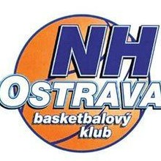

FIBA
Steel cup Ostrava 2020
4. – 6. 9. 2020

This year for category U14, U15
Boys born 2007, 2006

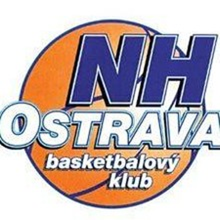
Dear friends!
Basketball club BK NH Ostrava with over 60 years history would like to invite you to the 57th traditionall strong Steel cup in the third biggest country in Czech Republic, Ostrava.
We would like to share some important information with you that you can find on the following pages.
Also in this year we expect teams from Czech Republic, Slovakia, Hungary, Serbia, Germany, Poland, Lithuania and other European basketball countries.

We wish you a pleasent stay in Ostrava.

Marek Stuchlý
General Manager
BK NH Ostrava z.s.
Email: marekstuchly@seznam.cz, tel. +420 603 877 855

Useful information
Date:
4. – 6. 9. 2020

Place:
Stadium Tatran, Cingrova 10, Ostrava

Category:
U14, U15

Playing time:
4x10 minutes stopped time, between 1-2 and 3-4 period is break 2 minutes and between 2-3 period is half break 10 minutes maximum.

Size of ball and hight of basket:
Regular FIBA baskets with ball size 7

Rules:
According to a FIBA rules 2019/2020

Guarentee:
Every team will play 5 matches at least

Prize:
Every team gets diploma, for first three teams will be prepared trophies and medals
MVP (the most valuable player)
All-stars (5 best player of the tournament without MVP player)

Coaches night:
5. 9. from 19:00 on the main stadium Tatran in VIP room

Water:
Still mineral water will be provided in the games for the teams. Tap water in Ostrava is drinkable.

Exact groups and timeschedules we will send you three weeks before a tournament.

Tournament fee:
Player/coach – 1300,- CZK (52 EUR)
includes: 2 night in luxury four star hotel Mercure, full-board meals in restaurant Septim (start with lunch on 6. 9. and cancel with breakfast on 8. 9.)
Starting fee – 2.500,- Kč (100EUR)

Includes also: tournament costs, trophies, madal, diplomas, presents etc.

Matches are played:
Hall Tatran
Cingrova 10, Ostrava
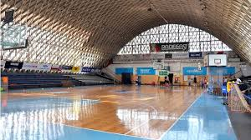

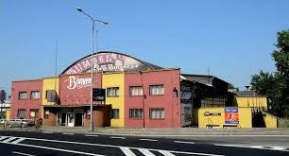

Accomodation with breakfast:
Hotel BRIONI https://www.hotelbrioni.cz/en/
Stodolní 8, Ostrava, 702 00, Czech Republic
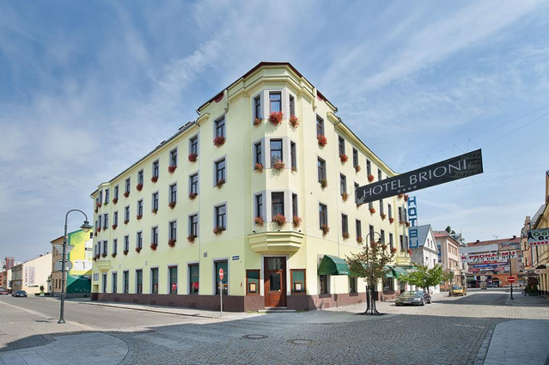
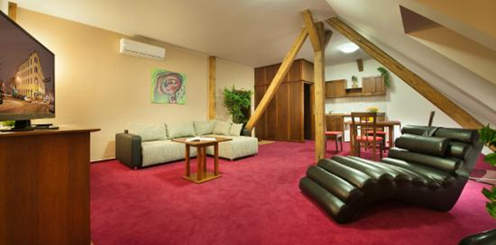

Meals:
Restaurant SEPTIM, Masná 1324/1, Ostrava
lunch, dinner
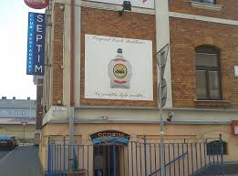

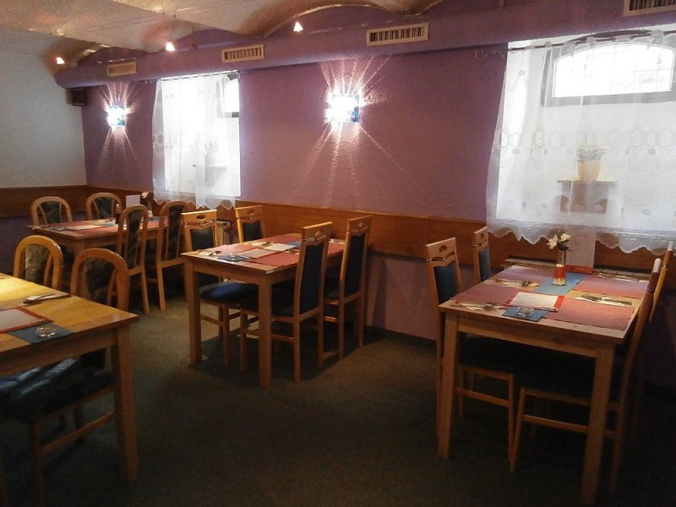

We wish you a happy stay in Ostrava!!!

